

2016 - 2017

Gifted Education Services

Resource Guide for Collaboration



Table of Contents

Rationale for Collaborative Work p. 3

Review of State Guidelines p. 5

How It Works p. 7

Collaboration Log p. 9

Collaboration Lesson Plan Form p. 11

Information for Parents p. 12

F.T.E. Information p. 13

Contact Information p. 13

Schools Participating in Collaboration p. 14

Resources:

Six Thinking Hats Planning Form

(Refer to p. 17-18 in Creativity x 4) p. 15

Encounter Lesson Planning Form

(Refer to p. 42-44 in Creativity x 4) p. 16

Questivities Planning Form

(Refer to p. 66-67 in Creativity x 4) p. 17

Scamper Planning Form

(Refer to p. 79-80 in Creativity x 4) p. 18

Socratic Seminar p. 19

Compare/Contrast Lesson p. 21

Mystery Lesson p. 23

Inquiry Lesson p. 29

**Rationale for Collaborative Work**



**Collaboration among All Educators**

**To Meet the Needs of Gifted Learners**

Giftedness is a complex phenomenon impacting the development of the whole child. Many specialists must work together to address the diverse academic, social and emotional aspects of the development of children with gifts and talents. It is imperative that educators in gifted, general, special education programs, and related professional services collaborate with one another and with parents/guardians and community members to ensure that students are properly identified for services to address their diverse advanced learning needs.

Most children identified as gifted are in heterogeneous classrooms served primarily by general education teachers. Depending upon the specific needs and abilities of these learners, numerous collaborative partners are needed to design and provide a range of appropriate services. Comprehensive, coordinated services for students with gifts and talents require a shared commitment and ongoing collaboration between general and gifted education professionals and families. Additionally, gifted students may benefit from collaborative planning and support from special education and related service professionals, including counselors, school psychologists, and social workers. Such collaborative efforts draw on the strengths of all school personnel and community resources to address students’ unique learning needs.

NAGC believes that high quality collaboration does not obviate the need for gifted education services or for gifted education specialists, but rather redefines the roles of educators in the plan for serving gifted and talented students. Collaboration calls for shared responsibility for recognizing indicators of giftedness and responding to those unique characteristics through more comprehensive and individualized programming options. Collaboration builds a community of insightful educators who create learning environments that are more challenging and engaging for all students, that better meet the needs of those who have been identified for gifted services, and that enable teachers to recognize potential giftedness in diverse populations.

Collaboration, then, should be part of a continuum of services provided from Pre-K through high school to meet the unique educational needs of gifted students. Examples of collaborative strategies that might be used to enhance the learning of students with gifts and talents include:

• Providing professional development for general education and special area teachers focusing on the characteristics of gifted learners and the varied manifestations of those traits and behaviors so that gifted learners, including those from diverse and underserved populations, are appropriately identified for services.

• Including special education teachers and school psychologists on gifted program evaluation teams to assist in diagnosis of and provision of appropriate services for twice-exceptional students.

• Providing ongoing support for general classroom teachers to assist with pedagogy designed to challenge all students, curriculum differentiation, and identification of advanced materials and to establish collaborative planning time with content specialists and gifted education specialists.

• Providing training and time for school counselors to work with gifted students and their families on issues such as affective development, social development, emotional adjustment, negotiating access to the next level of schooling early as appropriate, locating learning opportunities outside of school, providing information about scholarships, and college and career planning.

• Facilitating the connection between families and schools by providing practical suggestions for parents to help them work effectively with school personnel and by helping them locate community-based and other resources to support their children outside of school.

In today’s diverse classrooms, collaboration enhances understanding and trust among educators, helps promote connections between services in all educational fields, helps develop more positive attitudes toward gifted education, and increases opportunities for all students, including those with gifts and talents.

**State of Georgia Regulations Related to Program Delivery Models**

(See Georgia Rule 160-4-2-.38, Section (g), Curriculum and Services to Be Provided, Paragraphs 1 and 2)

**Indirect Services**

**Collaborative Teaching (K-12)**

A maximum of eight identified gifted students are placed as a group into an otherwise heterogeneous classroom. Direct instruction is provided by the students’ regular classroom teacher who collaborates with a designated gifted teacher. There must be substantial, regularly scheduled collaborative planning between the regular classroom teacher and the gifted teacher. The following requirements must be met to earn at the gifted FTE weight:

The collaborating gifted teacher must have a clear renewable GaPSC approved gifted education endorsement.

The gifted teacher, the regular classroom teacher, and the gifted student(s) (when appropriate) collaborate and document the development of differentiated instructional strategies, Georgia standards based curriculum, and evaluations practices.

The collaborating regular classroom teacher and gifted teacher must be provided adequate planning time which must be documented and approved by the LEA. In CPI, the regular education teacher is the teacher of record and the gifted program teacher in recorded in the consultative subject code.

The gifted education teacher must be given one full period each week or its monthly equivalent during which he/she has only gifted education collaborative planning responsibilities (as determined by the local system) for every three classes in which he/she has collaborative teaching responsibilities.

The total number of gifted students whose instruction may be modified through this collaborative approach may not exceed eight per class. For example, if the gifted program teacher is working with three classroom teachers during the first period of the school day, there may be no more than 24 gifted students (for whom curriculum is being differentiated divided among the three classes).

Instructional segments that have been modified for gifted learners may be counted at the gifted FTE weight if the gifted education teacher, and regular education teacher document the curriculum modifications made for the gifted students in the following way:

a. separate lesson plans which show the reason(s) why any student whose instruction is counted at the gifted FTE weight needs an advanced curriculum in that particular content area (e.g., National norm reference tests and/or benchmark tests, );

b. a time and discussion log of the collaborative planning sessions between the teachers

c. individual or small group contracts indicating the differentiated learning standards for the gifted student(s) and the alternative instructional strategies in which the gifted student(s) will be engaged.

Table 1:

Required Planning Time for Gifted Program Specialist in the Collaborative Teaching Model

|  |  |  |
| --- | --- | --- |
| Number of classes within which the gifted specialist collaborates | Number of segments that can be counted at the gifted weight | Number of minutes allotted for collaborative planning. |
| 1-3 | 1-24 | 45-60 |
| 4-6 | 25-48 | 90-120 |
| 7-9 | 49-72 | 135-180 |
| 10-12 | 73-96 | 180-240 |
| 13-15 | 97-120 | 225-300 |
| 16-18 | 121-144 | 270-360 |

*Georgia Department of Education, Dr. John D. Barge State School Superintendent*

*July 30, 2012 All Rights Reserved*

**How it Works**

1. Regular education and gifted teachers meet to discuss the specific needs of their students and identify a topic, process, or skill that might benefit from a differentiated lesson.
2. Regular education and gifted teachers collaboratively plan the lesson, including at least one element of differentation.
3. The gifted teachers presents the lesson to the students with the regular education teacher participating/observing.
4. The teachers meet to discuss their observations of the lesson and the students.
5. The teachers determine whether there are any parts of the lesson that would benefit from changes.
6. The gifted education teacher completes the Collaboration Log for this lesson.

1. The revised lesson is taught by the gifted teacher in another regular education classroom at the same grade level with the regular education teacher participating/observing.
2. Teachers meet to reflect on the results of the lesson presentation.
3. The gifted education teacher completes the Collaboration Log for this lesson.
4. On the 5th day of the month, all Collaboration Logs from the previous month are to be submitted to the Collaboration Coach.

The general education teacher and the gifted teacher have s**hared** responsibilites and should combine their expertise and efforts to provide services to ALL students.

|  |  |  |
| --- | --- | --- |
| *Regular Education Teacher* | *Gifted Teacher* | *Shared Roles* |
| Pre-, Formative and Summative Assessment | Plan and organize for differentiation | Analyze assessment data |
| Plan with standards prior to instruction | Identify and/or organized instructional resource materials | Analyze/evaluate student work |
| Organize differentiation | Analyze relative gifted testing data | Co-Plan / Co-Teach |
|  |  | Reflect, analyze, revise |

**What Works, What Doesn’t Work**

|  |  |
| --- | --- |
| *What Works* | *What Doesn’t Work* |
| Building relationships | Gifted teacher overseeing lesson plans and differentiation |
| Team effort approach | Gifted teacher writing lesson plans for regular education teacher to use with his/her students |
| Working with specialists, academic coaches, and classroom teachers | Gifted teachers giving websites and other materials to regular education teachers for them to peruse |
| Sharing resources | Just another meeting …. |
| Grade teams plan together with gifted teacher |  |

 **C O L L A B O R A T I O N L O G**

|  |
| --- |
| School: |
| Gifted Teacher: |
| Collaboration Date: |

Codes:

|  |  |  |
| --- | --- | --- |
| **A** Planned with regular education teacher | **B** Observed regular-education teacher implementing differentiated strategies | **C** Assisted regular-education teacher in developing higher-level thinking activities |
| **D** Modeled a lesson | **E** Prepared lessons/ activities for teacher | **F** Conferenced with regular education teacher(s) |
| **G** Developed rubrics for regular education teachers to use with gifted/high ability students | **H** Participated in professional learning related to the collaboration models | **I** Absent - Personal |
| **J** Absent - Sick | **K** Absent – Professional | **L** Other - Explain |

|  |  |
| --- | --- |
| **7** | ELA |
| **8** | Reading |
| **9** | Social Studies |
| **10** | Science |
| **11** | Math |

|  |  |  |  |
| --- | --- | --- | --- |
| **Date** | **Teacher(s)** | **Code(s)** | **Comments/Requests** |
|  |  |  |  |

|  |
| --- |
| **Specific Differentiation of Instructional Strategies**  **(Select all that apply)** |

|  |  |  |
| --- | --- | --- |
| Encounter * | Questivities * | Six Hats Thinking * |
| Socratic Seminar | Scamper* | Compare/Contrast |
| Mystery | Inquiry | Brainstorming |

|  |
| --- |
| **Assessment (Select all that apply)** |

|  |  |  |
| --- | --- | --- |
| Rubric | Reflection Log/Journal | Observation |
| Formal Quiz/Test | Checklist | Other: __________ |

|  |
| --- |
| Number of segments: (select one)  _________ONE (50 mins) ____________TWO (110 mins) |

**____________________________**

Gifted Teacher’s Signature (electronic signature is ok)

_______________________________ _______________

Collaboration Coach’s Signature Date

*Creativity: Using the Common Standards by Carolyn Coil.

*Collaboration Logs are to be submitted to the Collaboration Coach once a month. They are due on the 5th day of the following month. Please attach lesson plans to this form.*

**Collaboration Lesson Plan**

|  |  |
| --- | --- |
| School: |  |
| TAG Teacher: |  |
| Reg.Ed. Teacher(s) |  |
| Date: |  |

|  |  |
| --- | --- |
| Subject: |  |
| Standards: |  |
| Essential Question: |  |

|  |
| --- |
| Procedures: |

|  |
| --- |
| Assessment of Learning: |



*Insert local school information here.*

**Advanced Studies Department**

Dear Parents,

We are excited to announce that during the 2016-2017 school year, we will be participating in an Advanced Studies Collaborative Model. In addition to providing services for our gifted students in our traditional one day pull-out model, our TAG teachers will also work with gifted and regular education students on an additional day of the week. Strategies often associated with gifted education will now be used in the regular education classroom for the benefit of all students. The collaborative model will involve *all* students.

The goal of collaboration is for gifted specialists and generalists to combine efforts and expertise to accomplish more in the education of all levels of learners. Think of it as:

* Sharing of expertise between two or more teachers with the ultimate goal of better serving students
* Shared responsibility to plan and deliver differentiated education to high ability learners
* Consultation with each other to plan, implement and monitor the differentiated instruction

If you have questions about the collaborative model, you may contact **INSERT TAG TEACHER NAME AND E-MAIL ADDRESS HERE.**

Looking forward to great things,

**F.T.E.**

Gifted students may be counted for no more than two segments of collaboration for F.T.E. purposes. There is no separate course number for Collaboration.

No student will be counted for both pull-out TAG services and collaboration model services during the same F.T.E. period. Gifted students coded for collaboration on FTE Count Day cannot be served in the TAG classroom pull-out on that same day. Ex. If 4th grade meets on Tuesdays for TAG, they cannot be also counted as collaborative on Oct. 6, but you would be able to count the other grade levels (only 8 per class) that are receiving the collaborative service on Oct. 6.

(Students only receive the collaborative service on the day that they do not go to the TAG classroom)

Students are coded with a Program Code of “I” for each segment on FTE day. Ex. If collaboration takes place for Science and science is scheduled for 4th period, the “I” should be entered into the Instructional Segment 4 column

Delivery Code = 4

Content Code =

|  |  |
| --- | --- |
| 7 | ELA |
| 8 | Reading |
| 9 | Social Studies |
| 10 | Science |
| 11 | Math |

**Contact Information:**

The Fulton County Collaboration Coach is Kati Searcy. She currently also serves as a TAG teacher at New Prospect Elementary School, the Lead TAG Teacher for the Northeast Learning Community and an instruction for the gifted endorsement program. You may reach Kati at [searcy@fultonschools.org](mailto:searcy@fultonschools.org)

**Schools 2016-2017**

Esther Jackson ES TAG Teacher: Melissa Zappulla

Manning Oaks ES TAG Teacher: Shelly Neal

Mimosa ES TAG Teacher: Lynn Early

New Prospect ES TAG Teacher: Kati S

Findlay Oaks ES TAG Teacher: Lori Katz

River Eves ES TAG Teachers: Gayl Struletz and Kathy Mintz

Alpharetta ES Maryann D’amelio and Suzanne O’Brien

Cogburn Woods Ashley Rolader and Cynthia Henry

Roswell North Jessica Sevin and Susan Johnson

**Six Thinking Hats**® **Activities Form**

**Common Core Standards**

**Whole Class Activities**

**Directions: Thinking Hats Questions**

**White Hat Thinking (Facts)**

**Yellow Hat Thinking (Benefits)**

**Black Hat Thinking (Flaws or Problems)**

**Red Hat Thinking (Feelings)**

**Green Hat Thinking (Creativity**

**Blue Hat Thinking (Summarizing)**

**Assessment Mini-Rubric**

# Encounter Lesson Form

**Title**

**Common Core Standards**

**Directions**

**Boundary Breaker**

**Setting the Stage**

**Leading Questions**



**Differentiated Extenders**

**Questivities™ - __________________________**

****Project Activity****

**Directions**

# Common Core Standards

**Assessment Mini-Rubric for the Project Activity**

**Project Questions (Essential Questions answered through the Project Activity)**

**Questivities™ Thinking Questions**

1. List

1. Compare/contrast
2. What would happen if
3. Would you rather
4. How would you feel if
5. Why

1. How

**Active Question**

Make a list of questions a _______________ might ask _________________.

# SCAMPER Planning Form

**Common Core Standards**

**Background Activity**

**Directions for the SCAMPER Activity or Activities**

**Materials**

**Substitute**

**Combine**

**Adapt**

**Modify**

**Put to other use**

**Eliminate**

**Rearrange/Reverse**

**Concluding Activity**

**Assessment Mini-Rubric for Concluding Activity**

**How to Create and Use Socratic Seminars**

Purpose of Socratic Seminars

In a Socratic Seminar, participants seek to answer an essential question and gain deeper understanding of laws, ideas, issues, values, and/or principles presented in a text or texts through rigorous and thoughtful dialogue.

Steps for Socratic Seminars

#### Preparation:

#### Prior to the discussion, the teacher will select an appropriate text. All students will read the text prior to the discussion.

#### The teacher will develop questions for the discussion. Effective questions are open-ended and have no “right” answer.

#### Prior to the seminar, the teacher will determine which students will be in the inner circle and which in the outer circle. It works best if there are “talkers” in both groups.

**Seminar:**

* Students sit in one of two circles (inner circle for participants, outer circle for coaches).
* Teacher poses a question. The teacher may need to ask follow up questions to lead the participants to greater understanding of the text.
* Students respond to the question orally (inner circle) or in writing (outer circle).
* Teacher facilitates the seminar discussion by guiding students to a deeper and clarified consideration of the ideas of the text, a respect for varying points of view, and adherence to and respect for the seminar process.
* Students cite evidence from the text, ask questions, speak, listen, make connections, and add insight or new knowledge to discuss their point of view in regards to the opening question.
* Teacher takes notes for evaluative purposes but provides no verbal or nonverbal feedback that either affirms or challenges what the students say.  The teacher may ask follow-up questions; however, teacher questions are used sparingly and deliberately.
* At some point in the discussion (up to teacher discretion), the circles will switch. By doing so, they also switch roles (orally answering versus written).

Options for Assessing and Evaluating Student Work in Socratic Seminars

Student participation and understanding may be assessed and evaluated using the following methods:

* Rubric to assess student conduct, speaking, reasoning, listening, and/or preparation
* Checklist of positive and negative behaviors
* Student self-evaluation
* Peer evaluation

**Socratic Seminar Rules**

* **Speak so all can hear you.**
* **Speak without raising your hand.**
* **Listen closely.**
* **Refer to the text.**
* **Talk to each other, not just the leader.**
* **Ask for clarification if needed.**
* **Invite and allow others to speak.**
* **Consider all viewpoints and ideas.**
* **Know that you are responsible for the quality of the seminar.**

Sample Lesson Plan: Compare and Contrast President Hoover and President Roosevelt

Phase 1: Comparison

1. Students use a visual organizer to identify similarities and differences between two items.

Students will complete the side by side graphic organizer. Students will work in small groups to complete the graphic organizer, but will complete their own page. The graphic organizer will answer the following questions:

* How did they impact the government prior to being elected president?
* What was their opinion on how the government should be involved in the economy?
* In what ways did their decisions help the economy during The Great Depression?
* In what ways did their decisions hurt the economy during The Great Depression?
* How are they remembered today?

Using a highlighter, students will highlight the similarities on each side of the graphic organizer.

Phase 2: Conclusion

1. Students discuss the relationship between the items.

Using their graphic organizer students will participate in a class discussion. The following questions serve as the guide for the questions (The Strategic Teacher, page 78)

* Are Roosevelt and Hoover more alike or different? Why?
* What is the single most important similarity between Roosevelt and Hoover?
* What is the single most important difference between Roosevelt and Hoover?
* What effects did the similarities have on The Great Depression?
* What effects did the difference have on The Great Depression?

Phase 3: Application

1. Students apply what they have learned as a result of the comparison.

Students will create a wanted poster with their small group. Their poster will include the “wanted” traits and/or qualities needed in a president to get the United States out of The Great Depression.

Summarizing Activity/Assessment

Informal Assessment: Student participation in the Conclusion discussion, teacher will target students that are not actively participating to ensure understanding. Participation in the creation of the “Wanted” Poster will demonstrate understanding of the two Presidents.

**Sample Lesson: Mystery**

**The Mystery on Mount Everest**

By the mid-1920s, the North and South Poles had already been explored. It seemed that the only place left to explore on Earth was the highest mountain, Mount Everest, which is 29,035 feet (5 ½ miles) high. By 1921, no one had been above 24,600 feet high, and people were unsure about whether such a feat could ever be accomplished.

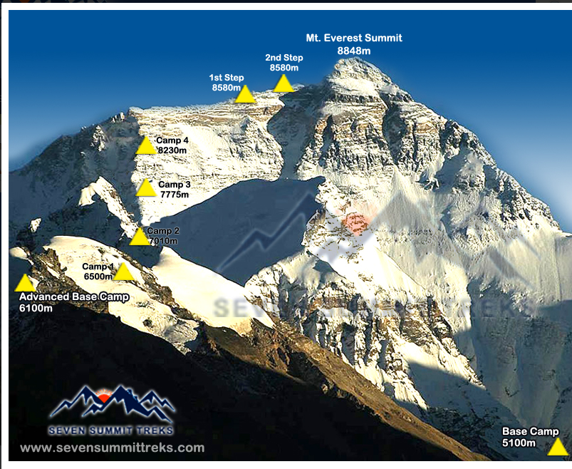

On June 6, 1924, George Mallory and Andrew Irvine set off from the top of North Col at 23,100 feet, hoping to reach the summit called the Second Step three days later. George Mallory had a lot of climbing experience and had been on two previous expeditions on Mount Everest in 1921 and 1922. When asked why he wanted to climb Mount Everest, he responded, “Because it is there.” Andrew “Sandy” Irvine had little climbing experience, but he was very good at repairing an oxygen apparatus, which was a very unreliable piece of equipment. Mallory had never used an oxygen apparatus in his past expeditions, but he came to realize that he would need to use one if he ever wanted to reach the top.

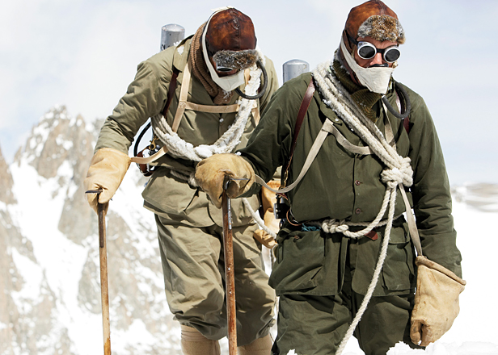

Sometime during their expedition, Mallory and Irvine met Howard Somervell. Mallory, who had forgotten to bring his camera, borrowed Somervell’s Kodak VPK camera to take pictures on the mountain. In the early afternoon of June 8, 1924, Noel Odell saw the two dark figures of Mallory and Irvine approach the Second Step. They seemed to be going strong, although Odell was surprised that they hadn’t made more progress. However, he felt sure they would make it to the summit. A snow squall struck the mountain shortly thereafter.

No one ever saw George Mallory or Andrew Irvine alive again. Whether either man reached the summit—almost three decades before Sir Edmund Hillary and Tenzing Norgay's historic 1953 climb—has been an open question for decades. Who were the first climbers to summit Everest continues to be a mystery that enthralls Everest followers and borders on obsession for a few historians.

**What ever happened to these two brave explorers?**

Cut up and distribute the following collection of clues to the students. The students may work in small groups.

The students will:

* organize the clues into categories that make sense to them
* glue the groupings on a sheet of butcher paper
* label their categories
* write their hypothesis across the top of the poster as to what happened to these explorers

Display all of the posters and have the students participate in a Museum Walk to compare/contrast their conclusions with the conclusions of other groups.

CLUES (to be cut out ahead of time)

After seeing Mallory and Irvine approach the Second Step, Odell went back to North Col and watched for them all night. He saw no sign of them.

Two days after Odell had seen Mallory and Irvine approach the Second Step, he returned to Mallory and Irvine’s high camp. He discovered that no one had been there since the explorers had left there two days before.

When Odell returned to Mallory and Irvine’s high camp, he found hardware from the oxygen apparatus all over the tent, possibly indicating that Irvine had been working on it before leaving.

In 1933, an ice axe was found at the 27,750-foot mark on the mountain. There were three nick marks on it, which was the same type of mark Irvine used to put on all of his belongings.

In 1960, a Chinese expedition successfully completed the Second Step climb, but only with the aid of ladders, ropes, and anchors. Even with the aid of the equipment that Mallory and Irvine had not had, the team still had to stand on each other’s shoulders with their boots and gloves off, resulting in frostbite and loss of toes.

In the 1930s, a working torch and emergency flares were found at Irvine and Mallory’s camp. They had left them behind.

In 1975, Wang Hongbao, a Chinese explorer, went for a twenty-minute walk away from his camp on Mount Everest. He discovered a body 750 feet directly below the spot where the ice axe had been found.

Hongbao recognized the body he found as “English dead,” because of the style of clothing. When he touched the clothing, it disintegrated in his hands, indicating that the body had been there a number of years.

Prior to 1975, no other English bodies had been lost on the mountain except Mallory and Irvine’s.

Hongbao did not tell anyone about his discovery until 1979, but he died in an avalanche the next day.

Odell’s last sighting of Mallory and Irvine is considered valid, because he is a trained geologist.

Odell later changed his story and claimed that he last saw them on the First Step.

In 1986, an expedition on Mount Everest discovered 2 twin air tanks belonging to a British expedition in 1922. The 1986 expedition was trying to find Mallory and Irvine, but a terrible snowstorm prevented them from reaching the search area.

The day before seeing his last sight of Mallory and Irvine, Odell received a note from Mallory stating that he intended to leave camp the following morning with 2 bottles of oxygen.

In 1999, 2 bottles of oxygen from 1924 were found on the mountain.

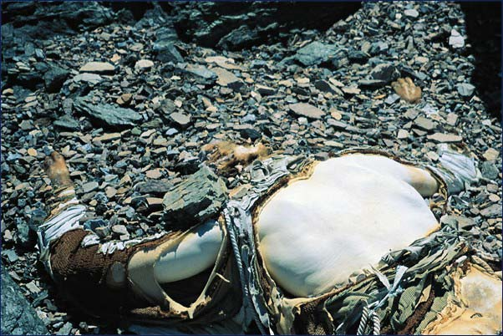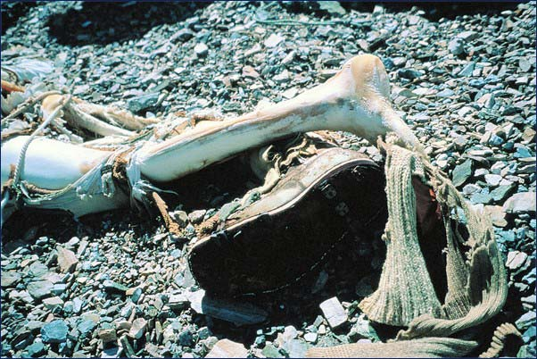

This body contained letters from Mallory’s family.

Another camera, the same model

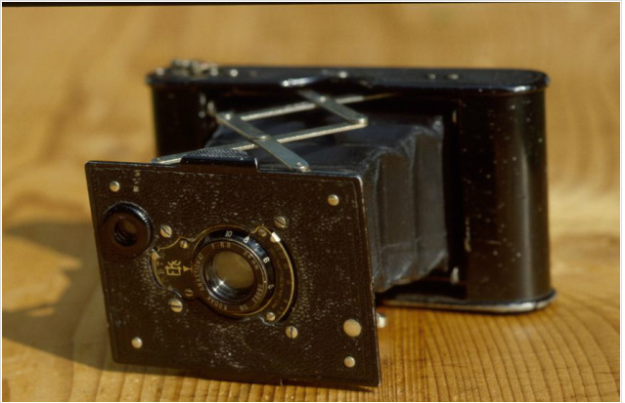

The “Solution” should be shared after students after completed the Museum Walk.

In May of 1999, a team set forth with metal detectors to try to look for the body that had been found in 1975 by Hongbao. The metal detectors would be used for finding ice axes, nails, boot soles, backpack frames, oxygen canisters, or Somervell’s camera. A GPS unit would be used to mark the sites where the ice axe was found, the body was found in 1975, and Odell last spotted Mallory and Irvine.

On May 3, 1999, the Mallory and Irvine Research Expedition found the body that Hongbao had discovered. The body had a rope around its waist, and the team could tell by the fractured leg, abrasion on the shoulder blade, deformed elbow, and broken ribs that the person had died in a fall. The body was wearing a jacket with blood on it, goggles, a flannel shirt, wool long johns, and knit leggings. On closer examination, the expedition team found that the clothing labels had George Mallory’s name on them. The clothes’ pockets also contained letters written to Mallory from his family. The expedition team removed everything from the body, covered the body with rocks, and returned all of Mallory’s belongings to the British Museum in London for examination.

The team returned to Mount Everest in April of 2000 to try to find Irvine and the camera, but they were unsuccessful. Although part of this mystery has been solved, two big mysteries still remain. Where is Irvine’s body? Did the pair ever reach the top of the Second Step, becoming the first to do so? Perhaps if the camera is ever found, the remainder of this mystery will be solved.

Instructions for an Inquiry Strategy Lesson

The purpose of an inquiry lesson is to expose the students to convergent, logical thinking in a fast format. Students must phrase questions in terms that can be answered “yes” or “no” which promotes clear and logical thinking. This strategy is ideal as an introduction to a unit or an idea. It is to be very quick.

Give each team of 3 students a copy of a mystery photo or a mystery item.

Provide some general background information about the object.

Explain to students that they are to determine what the object is / what is what used for / where it came from, etc.

Directions for students:

1. By yourself, come with a hypothesis.
2. With your team, discuss your ideas, and together, come up with one initial hypothesis.
3. Craft five “yes or no” questions that you will ask the teacher. Encourage them to begin with very broad vs. specific questions. For example, asking if it is a living thing is a better start than asking if it is a dog. Tell them to only include one question. For example, asking if it is a brown dog is really asking two questions – it is brown? is it a dog?

Going around the room, one group at a time, each group can ask on of their questions. All groups will ask one question before any group asks a second question.

As you answer the questions, keep track of the answers with a Yes/No table on the board.

When all questions have been asked (and the object has not yet been identified):

1. With your team discuss your ideas and come up with a second hypothesis.
2. Write five “yes or no” questions that you will ask the teacher.

This procedure continues for three round.

When a team thinks they have a final hypothesis, they are to state it.